1. **Queries to insert data in your database relations OR the program to generate test data. Screen captures that shows that data was inserted successfully**

customer:

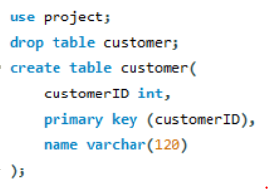

customer data:

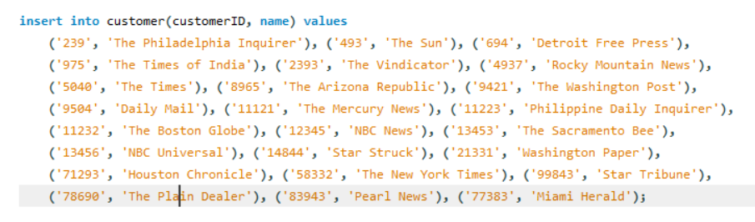

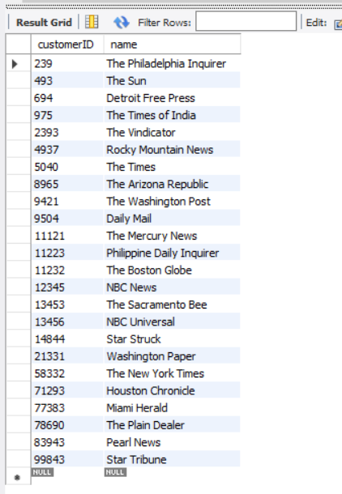

article:

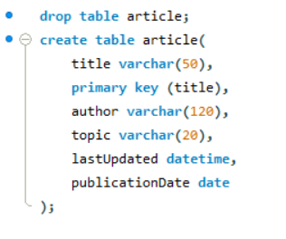

article data:

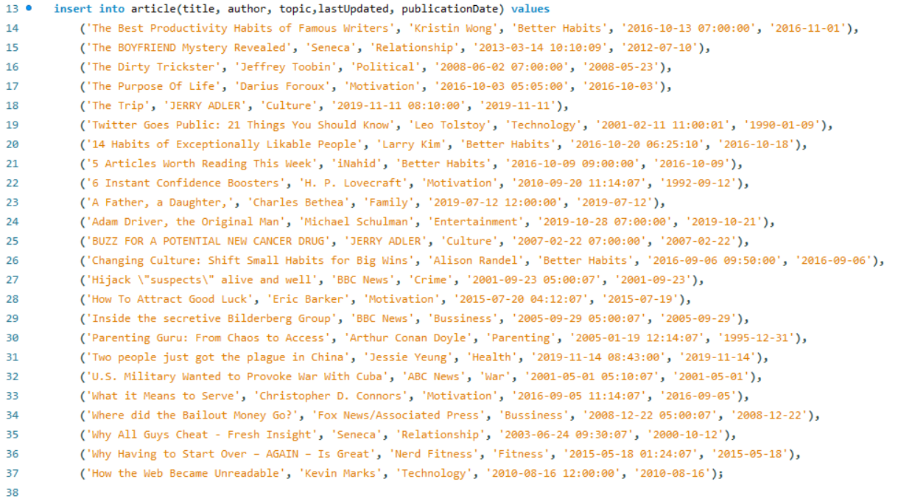

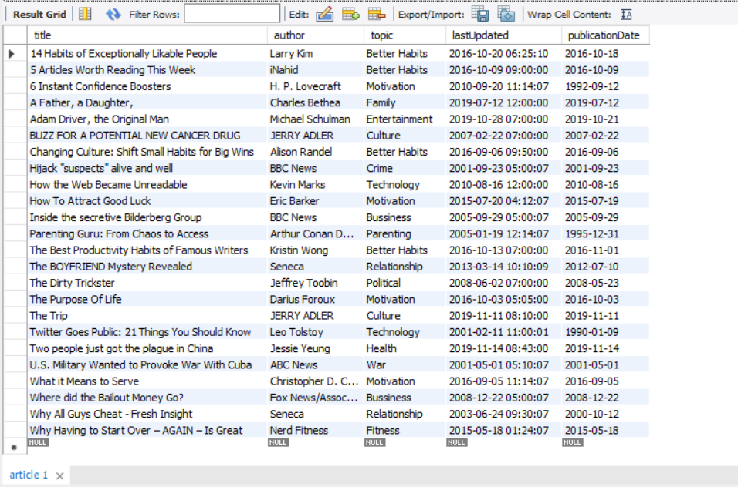

billing:

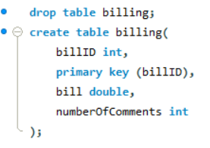

billing data:

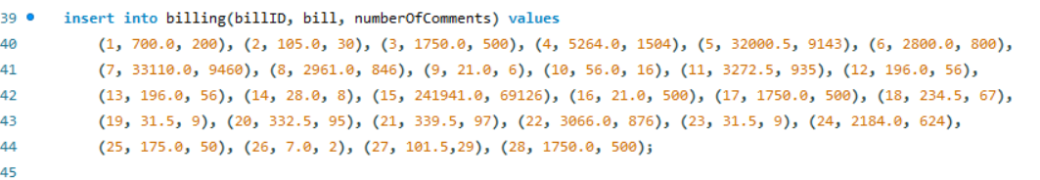

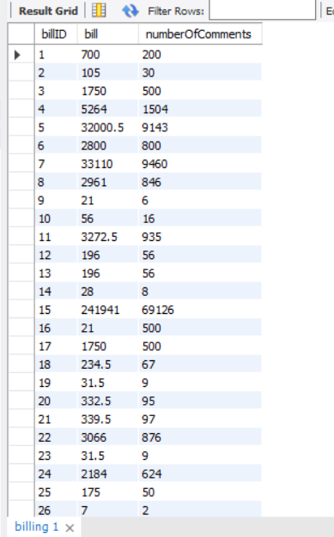

user:

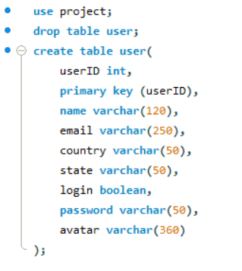

user data:

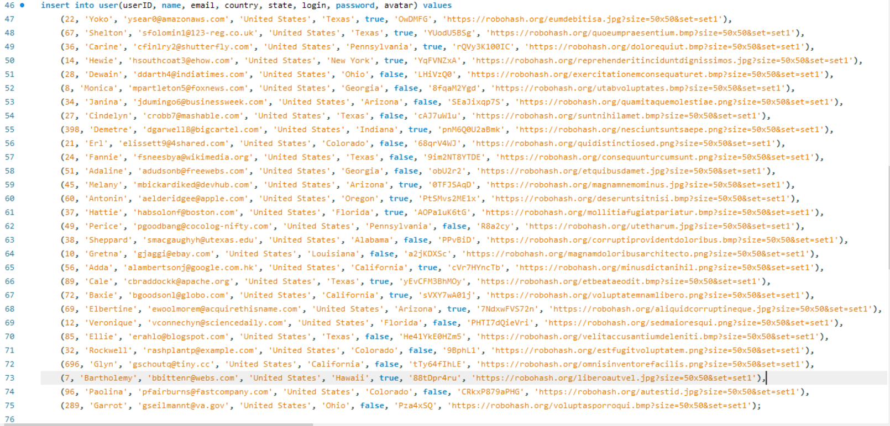

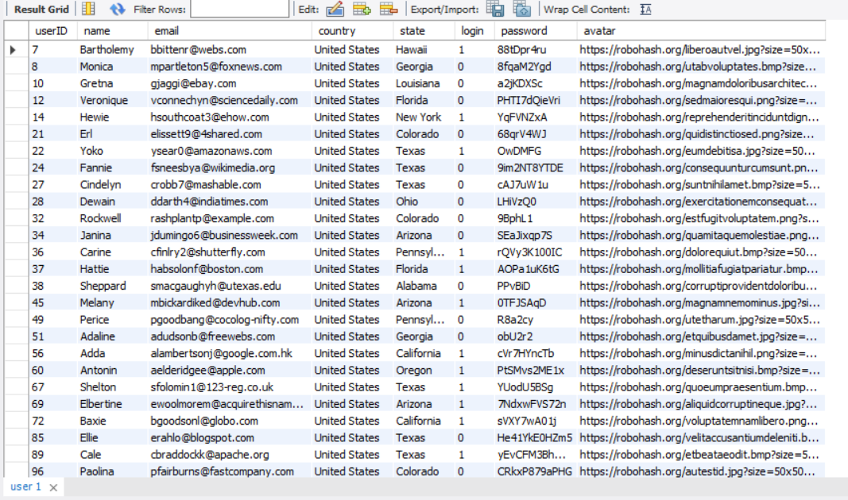

comment:

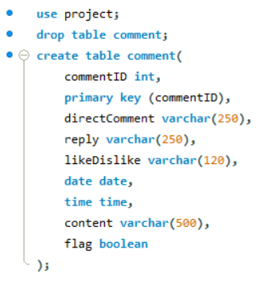

comment data:

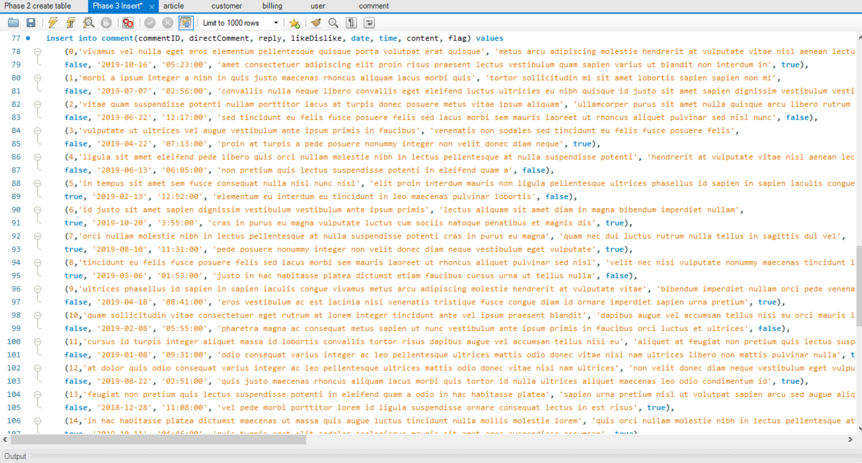

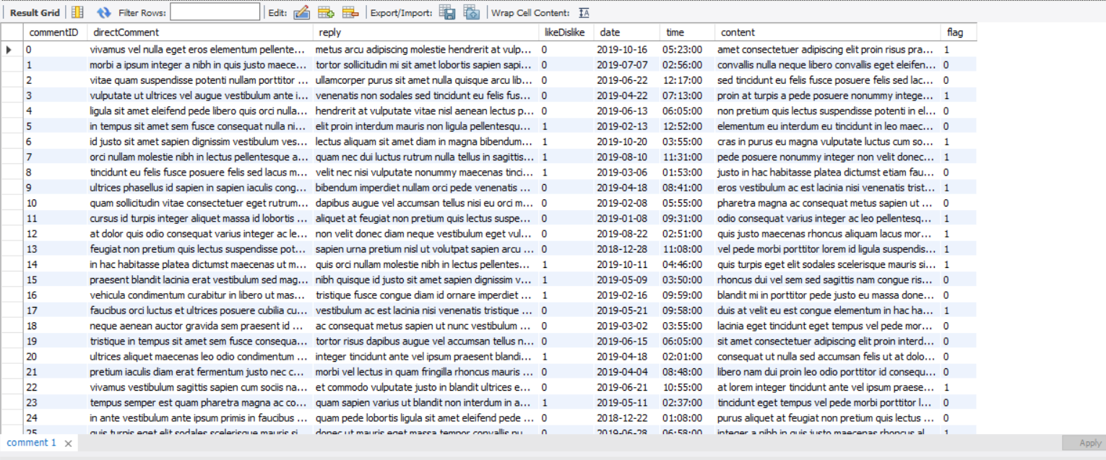

1. **Describe the challenges you met while implementing this phase of the project**

Inserting so much data was very tedious however I realized I could use a data generator such as <https://mockaroo.com/>. I had to change the primary keys of a few tables since they were being referenced in other tables. After changing the primary keys I went ahead and changed the E-R diagram and relation schema of Phase 1 and Phase 2.

I have two tables called `comment` and `derComment`, and they both have the attribute `flag`. My `flag` is a boolean. What I want to do is if `flag = 1` then access derComment table and if `flag = 0` then derComment does not need to be accessed. I had to use trigger but I was not sure how to implement it, so I asked Dheera.

Phase 1: E-R diagram

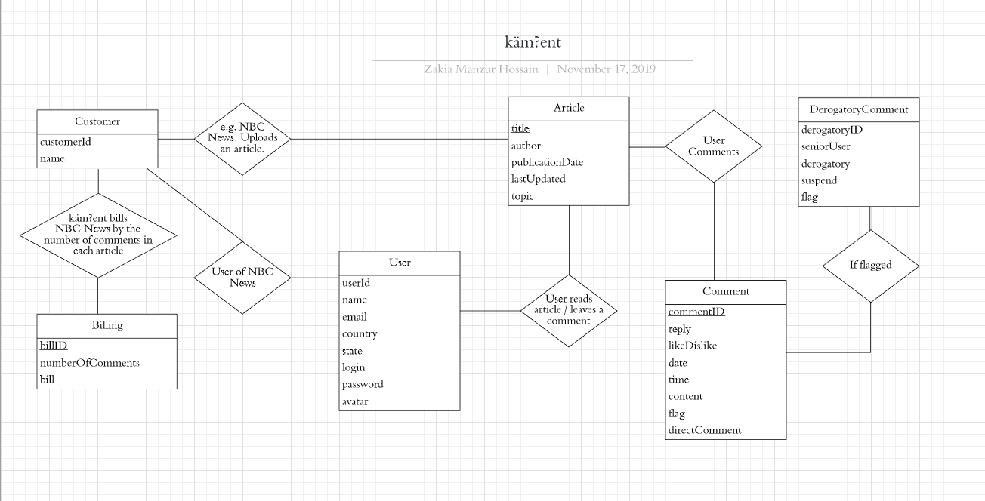

Phase 2: Relation Schema

